THE POWER OF PRAYER

Why does the Satan always carry a pitchfork?

By Rabbi Aaron Dovid Poston aarondovid@yiboneh.com
Recommended Reading background material about the Satan http://www.beingjewish.com/basics/satan.html

Rambam Hilchot Ishut Chapter 15:7
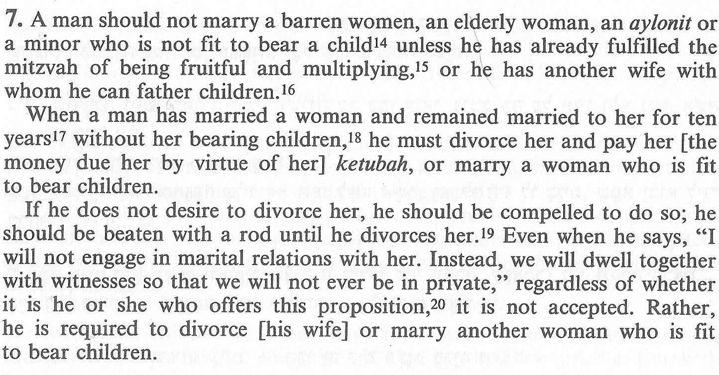
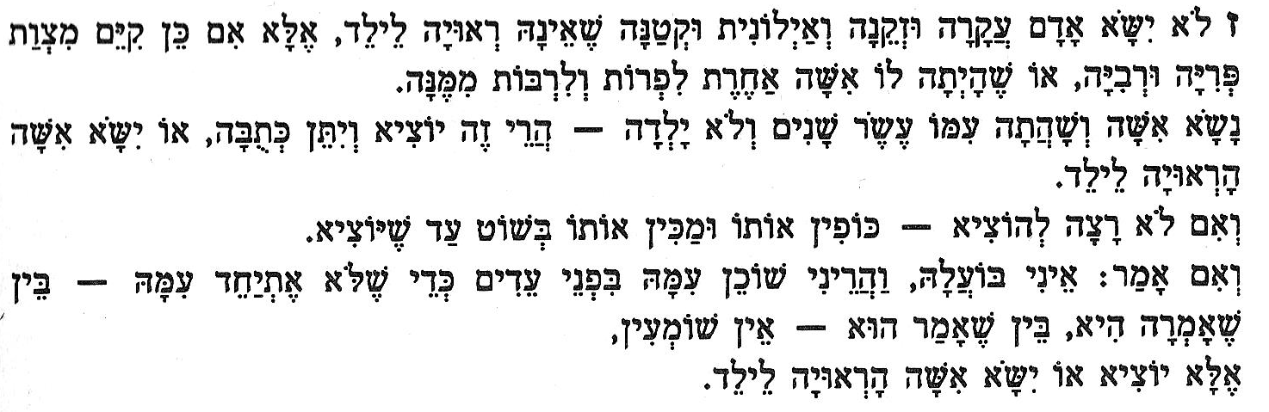
Source for this law is found in Genesis 16:3 Sarah gave Hagar to Abraham “After ten years in which Avram had lived in the Land of Canaan”
מִקֵּץ֙ עֶ֣שֶׂר שָׁנִ֔ים לְשֶׁ֥בֶת אַבְרָ֖ם בְּאֶ֣רֶץ כְּנָ֑עַן

Genesis 25: 20-21
20.) And Isaac was forty years old when he took Rebecca the daughter of Bethuel the Aramean of Padan Aram, the sister of Laban the Aramean, to himself for a wife.
וַיְהִ֤י יִצְחָק֙ בֶּן־אַרְבָּעִ֣ים שָׁנָ֔ה בְּקַחְתּ֣וֹ אֶת־רִבְקָ֗ה בַּת־בְּתוּאֵל֙ הָֽאֲרַמִּ֔י מִפַּדַּ֖ן אֲרָ֑ם אֲח֛וֹת לָבָ֥ן הָֽאֲרַמִּ֖י ל֥וֹ לְאִשָּֽׁה
21.) And Isaac prayed to the Lord opposite his wife because she was barren, and the Lord accepted his prayer, and Rebecca his wife conceived.
וַיֶּעְתַּ֨ר יִצְחָ֤ק לַֽיקוָק לְנֹ֣כַח אִשְׁתּ֔וֹ כִּ֥י עֲקָרָ֖ה הִ֑וא וַיֵּעָ֤תֶר לוֹ֙ יְקוָ֔ק וַתַּ֖הַר רִבְקָ֥ה אִשְׁתּֽוֹ
Rashi on verse 20
forty years old: For when Abraham came from Mount Moriah, he was informed that Rebecca had been born. Isaac was then thirty-seven years old, for at that time Sarah died, and from the time that Isaac was born until the “Binding” [of Isaac], when Sarah died, were thirty-seven years, for she was ninety years old when Isaac was born, and one hundred and twenty-seven when she died, as it is stated (above 23:1): “The life of Sarah was [a hundred and twenty seven years.”] This makes Isaac thirty-seven years old, and at that time, Rebecca was born. He waited for her until she would be fit for marital relations-three years-and then married her. — [From Gen. Rabbah 57:1; |  | בן ארבעים שנה: שהרי כשבא אברהם מהר המוריה נתבשר שנולדה רבקה, ויצחק היה בן שלשים ושבע שנה, שהרי בו בפרק מתה שרה, ומשנולד יצחק עד העקידה שמתה שרה שלושים ושבע שנה, ובת תשעים היתה כשנולד יצחק, ובת מאה עשרים ושבע כשמתה, שנאמר (כג א) ויהיו חיי שרה וגו', הרי ליצחק שלושים ושבע שנים ובו בפרק נולדה רבקה, המתין לה עד שתהא ראויה לביאה שלש שנים ונשאה:

The Gemorah in Succot 14a discusses aspects of handles of food that would be considered as either handles or actual food in regard to susceptibility to and ability to conveying spiritual impurity in which a pitchfork was mentioned. (The same teaching appears in Yevamos 64a)

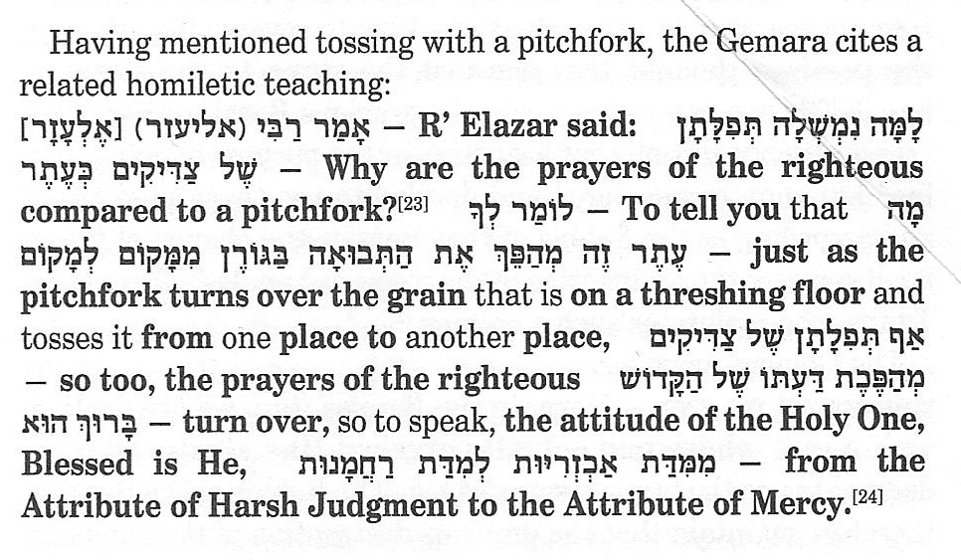

Artscroll commentary on above Gemora
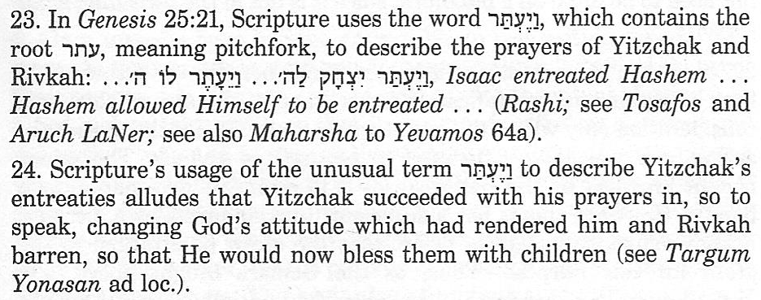
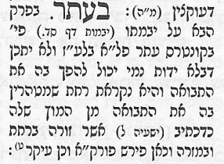
Tosophot on Succos 14 a: bottom line says this utensil is a Winnowing Fork which we identify as a (pitch) fork

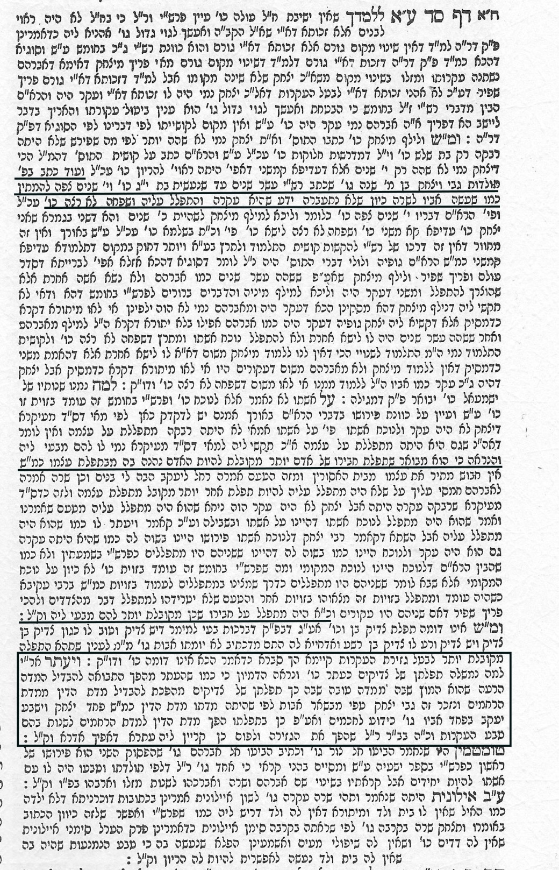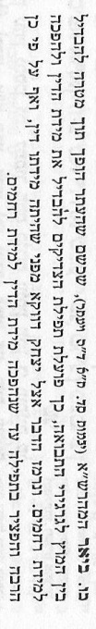
The Maharshah in Yevamos 64b says that just as the pitchfork turns over the pile of grain with the goal to separate the chaff from the kernels, so too, the function/influence of the prayers of the righteous are to distinguish/separate/divide the attribute of judgement and reverse/turn over to the attribute of mercy. This matter is specifically alluded to with Yitzchak because embodies the attribute of judgment/din. Never-the-less, Yitzchak prayed excessively until he was able to overturn the attribute of judgement to mercy.
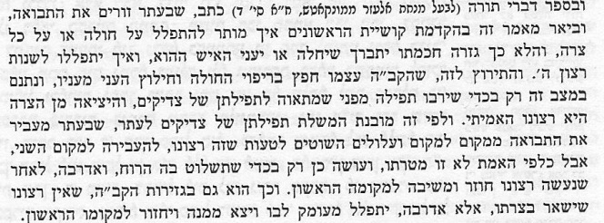
The Sefer ‘Divrei Torah’ authored by Reb Menachem Elazar from Munkatch writes that the pitchfork scatters/winnows the grain.
The clarification of this statement was included in an introduction posed as a question by Rishonim: HOW IS IT PERMITTED TO PRAY FOR A SICK PERSON OR ANYONE WHO IS IN DISTRESS? Was it not a Heavenly Decree by the Wisdom of The Blessed One that this person should be sick or that he should suffer? How can one pray to change the Will of the Al-Mighty?
The answer to this is the following: The Holy One Blessed is He, Himself, desires this person to be healed from his illness and that the person is saved from calamity/poverty. Hashem places this person in the particular situation only to increase PRAYER – because He desires the prayers of the Righteous, so the removal of this person from this situation of calamity is His true desire.
According to this, we understand this analogy of the prayers of the righteous to a pitchfork, because the pitchfork moves/transfers the grain from one place to another. Fools are likely to be mistaken that this is His will, (and that the goal of moving the grain is just to place it into a second location). However, the truth is not this goal, but it is performed only in order that the WIND controls the separation process.
The opposite is true, after he performs the act according to his will/desire, he returns it to its original place. So too, with the decrees of The Holy One Blessed is He, it is not His will for the person to remain in the calamity, but rather the opposite, ONE SHOULD PRAY FROM THE DEPTHS OF HIS HEART, and that he should be removed from it and return to the original place.

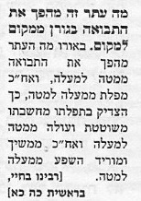
Rebbeinu Bechya writes: In light of the fact that just as the pitchfork overturns the grains from BELOW to ABOVE, and then afterwards it reverses/falls from ABOVE TO BELOW.
So too , the righteous in their prayers – as his thoughts are roaming/wandering and goes up from BELOW to ABOVE, and afterwards he draws down the providence/abundance from ABOVE to BELOW.

The Meeiri on Yevamos 64a says: A person must never abandon hope from praying – because the screen/curtain (of the inner sanctum) is never locked by way of vigilance. As the verse says, Gen 25:21 “Yitzchak entreated Hashem…Hashem allowed Himself to be entreated” Why are the prayers of the Righteous compared to a pitchfork? Similarly it was said of Sarah our Mother, that she was barren (incapable of bearing a child) , that she didn’t even have a womb, never-the-less nature was changed and she gave birth.

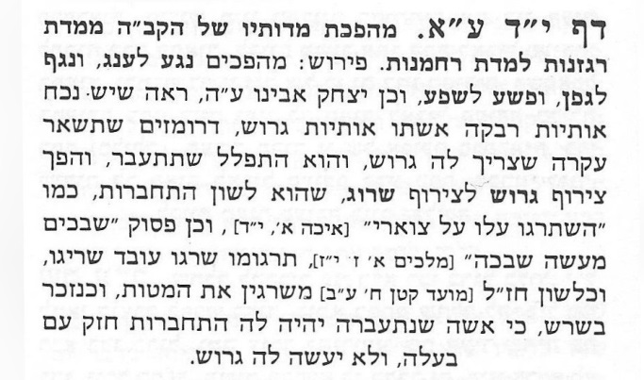
The Ben Ish Chai/Sefer Biniyahu
Turns over the attributes of The Holy One Blessed be He, from ANGER (Ragzanut) רגזנות to MERCY (Rachamim) רחמים :
This means: To transform Affliction נגע (Negah) to Pleasure ענג (Oneg),
and PLAGUE נגף (Nagaf) to Grapevines (Gefen) גפן
and TRANSGRESSION/FAITHLESSNESS (Peshah) פשע into PROVIDENCE/ABUNDNACE (Shefa) שפע.
So too, Yitzchak our father, peace be upon him, saw that there was IN FRONT OF HIM (NOKACH) נכח presently as arranged the letters of RIVKA רבקה his wife written as the word DIVORCED (GARUSH ) גרוש which hinted to him that she would remain barren and he would need to divorce her. So he prayed that she should conceive. He turned the word combination of GARUSH גרוש to SARUG שרוג, which is a language of attachment and enjoinment, as said in Eicha 1:14 and the Targum on verse I Kings 7:17. Moed Katan 8b - This refers to the Connecting of the Beds, as mentioned by Rashi, when the wife becomes pregnant there will be a stronger attachment with her husband and he is unlikely to divorce her.
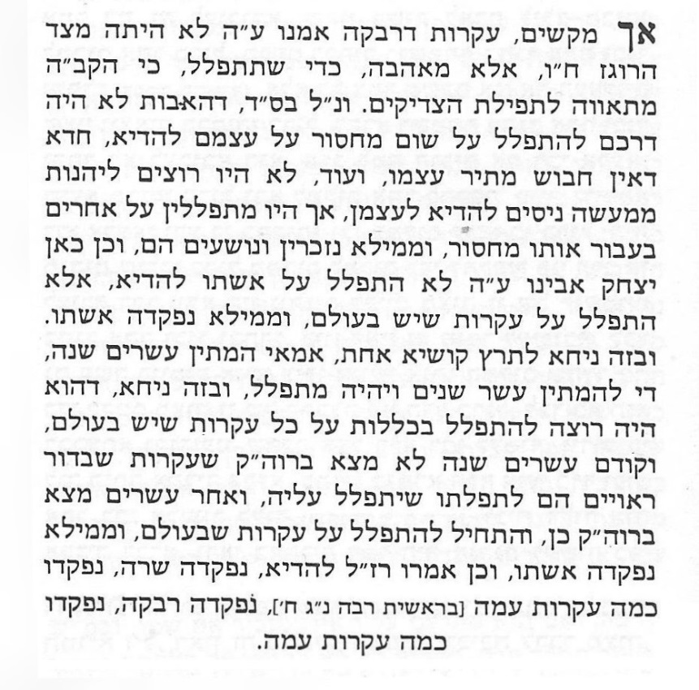
However, it is reasonable to ask, the infertility of Rivka was not due to any aspect of anger (G-d forbid), but was from love, in order that one should pray, for Hashem desires the prayers of the Righteous.
It seems that it was not the way of the forefathers to pray for anything that they were specifically lacking, as we know that a prisoner cannot free himself. Furthermore, they didn’t want to benefit from the results of miracles performed on their account. However, they would pray for others because of their lack, and as a result they would be remembered and would be saved.
So too with Yitzchak our father, peace be upon him, did not pray specifically for his wife, but rather he prayed for all the barren women in the world. As a result, his wife was remembered. This (answer) rests well to answer one question, why did he wait 20 years? It was enough to wait 10 years and then pray. Here is the answer: He wanted to pray in general for all the barren women in the world, but before 20 years he didn’t yet find through the Holy Spirit that the barren women in that generation were worthy for him to pray for them. After 20 years he found through the Holy Spirit to do so, and so he started to pray for all the barren women of the world. As a result his wife became pregnant. So too, the Sages tell us explicitly , that when Sarah became pregnant, so too, many women (in her generation) became pregnant as well. When Rivka became pregnant also many other women became pregnant.

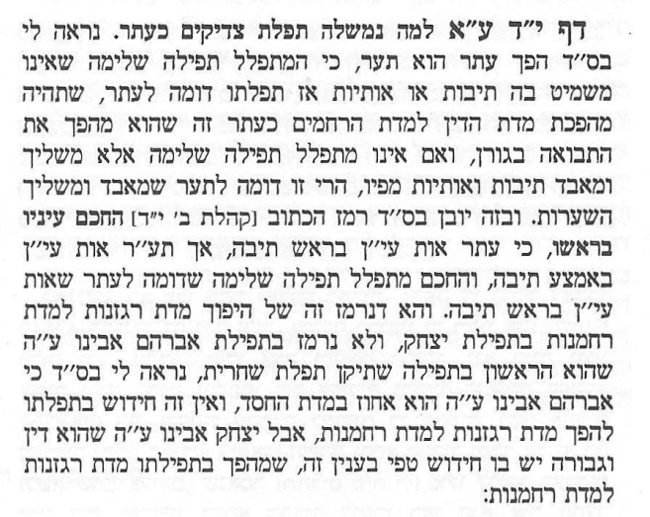
The Ben Ish Chai
Sefer Ben Yehudai
Why are the Prayers of the Righteous compared to a Pitchfork? I can explain with the help of G-d, that the turning over the word (through different letter configuration) PITCHFORK (ETAR) עתר and RAZOR BLADE (TAAR) תער.
When one prays properly by not omitting words or letters, then his prayers are like a pitchfork, and he will be able to successfully overturn the attribute of judgment towards mercy just as a pitchfork overturns the grains in the granary. If one doesn’t pray properly, but throws around and loses/destroys words and letters from his mouth, this is similar to a razor blade that destroys and causes a loss of hair.
Now we can understand a hint through this verse, Ecclesiastes (Kohelet) 2:14 “The wise man has eyes in its beginning…” הֶֽחָכָם֙ עֵינָ֣יו בְּרֹאשׁ֔וֹ as the PITCHFORK (ETAR) עתר has the letter EIYEN ע at the beginning of the word, whereas the word RAZOR BLADE (TAAR) תער has the letter EIYEN ע in the middle of the word. The wise person will pray properly, similar to a pitchfork which has the letter EIYEN ע at its head/beginning. This is alluded to by the overturning of the attribute of anger toward the attribute of mercy through the prayer of Yitzchak, but is not alluded to in the prayer of Abraham our father, peace be upon him – since he was the first in prayer as he instituted the Morning prayer (Shachrit). It seems that because Abraham was so well connected with the attribute of Mercy, there is novel thought that his prayers turned over the attribute of judgment towards mercy, but Yitzchak who is the embodiment of judgment and might, this proves to be a greater novelty in this regard, that he overturned these attributes.

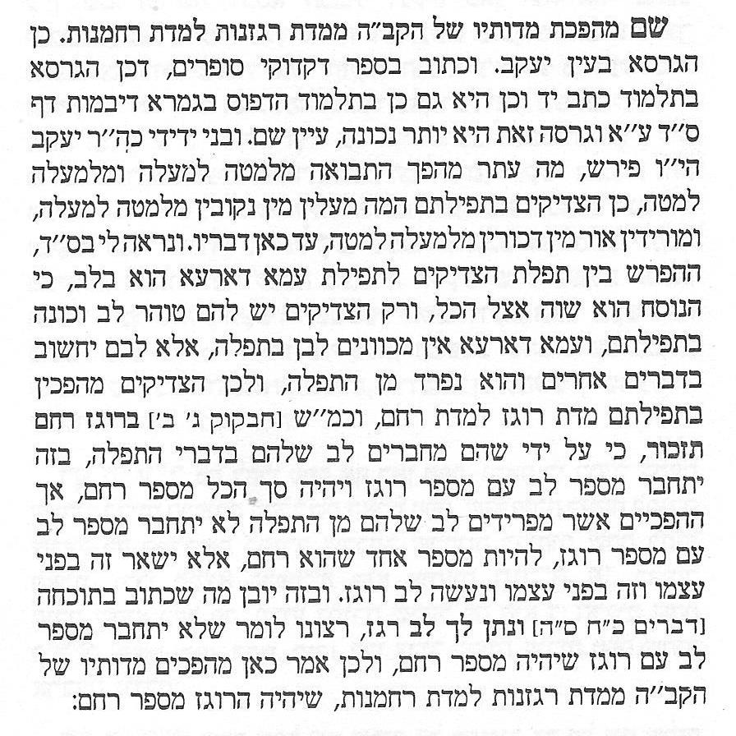
Here the Ben Ish Chai proves that the correct word used throughout the Talmud is RAGZANUT (Anger), just as in Yevamos 64b
My dear friend Rebbi Yaacov explains: Just as the pitchfork (Etar) overturns the grains from below to above, they are raised up from the FEMALE (Nukvin) aspect, from below to above, and then descend through the light of the MALE (Duchrin) aspect from above to below.
With the help of G-d, I can explain that the difference between the prayers of the righteous and the ignorant masses lie in the HEART לב (LEV = 32)
Even though the words of prayer are the same for everyone, it is only the righteous ones who have a pure heart and correct intent during their prayer, whereas the ignorant masses do not have the proper intent in their hearts during prayers. Rather their hearts are thinking of other matters and they are separate/distant while involved in prayer. Whereas the Righteous ones are overturning the attribute of ROGEZ / Anger to the attribute of RACHEM/Mercy, as said by Habakuk 3:2 “In anger You shall remember to have mercy”. בְּרֹ֖גֶז רַחֵ֥ם תִּזְכּֽוֹר so by combining/connecting ones HEART לב (LEV = 32) with the words of prayer, this will connect with the (number) for ANGER רוגז (ROGEZ = 216) which equals the gematria of MERCY רחם (RACHEM = 248) . However, by doing the opposite by separating their hearts from the prayer – they do not connect the number HEART לב (LEV = 32) with the number for ANGER רוגז (ROGEZ = 216) to be the one complete number for MERCY רחם (RACHEM = 248). But rather they leave each one separate on its own and they become an ANGRY HEART. Now this is understood what was mentioned in the Rebuke Deuteronomy 28:65 “And among those nations, you will not be calm, nor will your foot find rest. There, the Lord will give you a trembling heart, dashed hopes, and a depressed soul.” וּבַגּוֹיִ֤ם הָהֵם֙ לֹ֣א תַרְגִּ֔יעַ וְלֹא־יִֽהְיֶ֥ה מָנ֖וֹחַ לְכַף־רַגְלֶ֑ךָ וְנָתַן֩ יְקוָ֨ק לְךָ֥ שָׁם֙ לֵ֣ב רַגָּ֔ז וְכִלְי֥וֹן עֵינַ֖יִם וְדַֽאֲב֥וֹן נָֽפֶשׁ meaning to say because the Heart was not connected with the Anger which comes to Mercy. This is why it is said here (that the prayers of the Righteous ) overturn the attributes of HASHEM from Anger toward Mercy, that the ANGER (with the HEART) turns to Mercy.

RAMBAM: Rabbi Moses ben Maimon, commonly known as Maimonides, and also referred to by the acronym Rambam, was a medieval Sephardic Jewish philosopher who became one of the most prolific and influential Torah scholars of the Middle Ages (1135-1204)
RASHI: Shlomo Yitzchaki, today generally known by the acronym Rashi, was a medieval French rabbi and author of a comprehensive commentary on the Talmud and commentary on the Tanakh (1040-1105)
MAHARSHA: Shmuel Eidels, was a renowned rabbi and Talmudist famous for his commentary on the Talmud, Chiddushei Halachot. Eidels is also known as Maharsha (1555-1631)
TOSOPHOT: are medieval commentaries on the Talmud. They take the form of critical and explanatory glosses, printed, in almost all Talmud editions, on the outer margin and opposite Rashi's notes.(1060-1320)

Rabbi Menachem Elazar Munkatch (1871-1937)

Rabbeinu Bahya ben Asher ibn Halawa, also known as Rabbeinu Behaye, was a rabbi and scholar of Judaism. He was a commentator on the Hebrew Bible. He is considered by Jewish scholars to be one of the most distinguished of the Biblical exegetes of Spain (1255-1340)

M’eeri

Ben Ish Chai - Yosef Hayim (1 September 1835 – 30 August 1909) (Iraqi Hebrew: Yoseph Ḥayyim; Hebrew: יוסף חיים מבגדאד) was a leading Baghdadihakham (Sephardirabbi), authority on halakha (Jewish law), and Master Kabbalist. He is best known as author of the work on Halakha Ben Ish Ḥai (בן איש חי) ("Son of Man (who) Lives"), a collection of the laws of everyday life interspersed with mystical insights and customs, addressed to the masses and arranged by the weekly Torah portion.

